**Classify Crime**

**Source:** book

**Title:** [**Crime classification manual: A standard system for investigating and classifying violent crime**](https://books.google.com/books?hl=zh-CN&lr=&id=j4CNiiDyOFQC&oi=fnd&pg=PT18&dq=classify+crime&ots=aGsMmFeNsk&sig=3C1bFfMaIAGXMMXSYcE6xViUq4c)

Crime classification Manual :motivation：

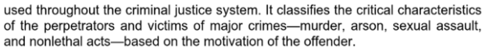

**Source:** Office for National Statistics

**Title:** The impact of crime on victims and society: March 2022

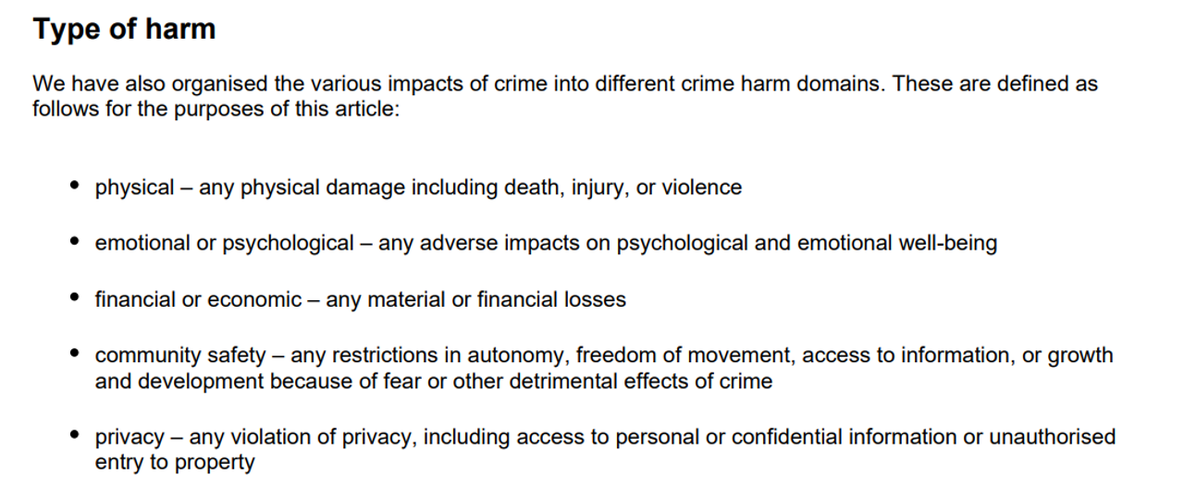

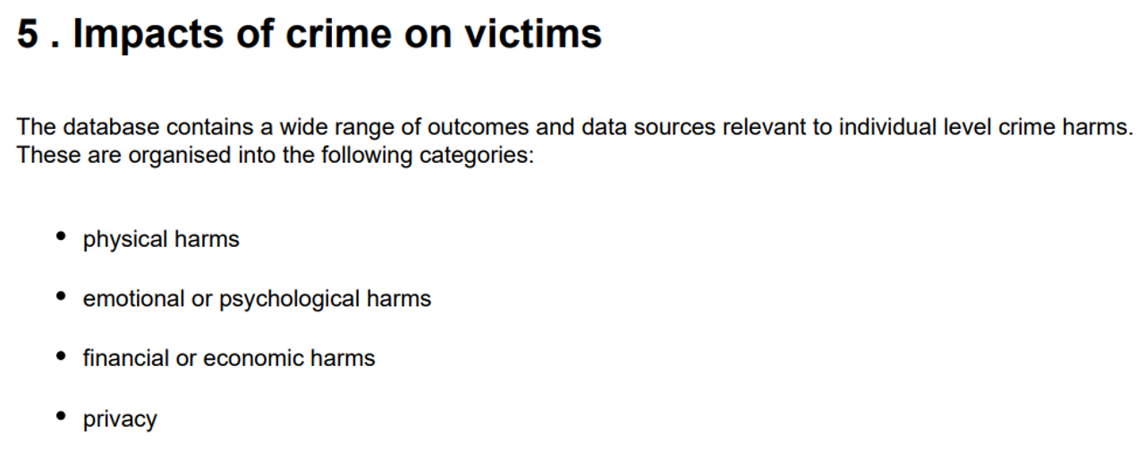

**Source:** American criminal law

**Chapter:1.4 Classification of Crimes**